SoftwareAnalogFilters response to strain
Blue – Raw Signal
Red – Filtered Signal

1.
Mov avg (window 10)
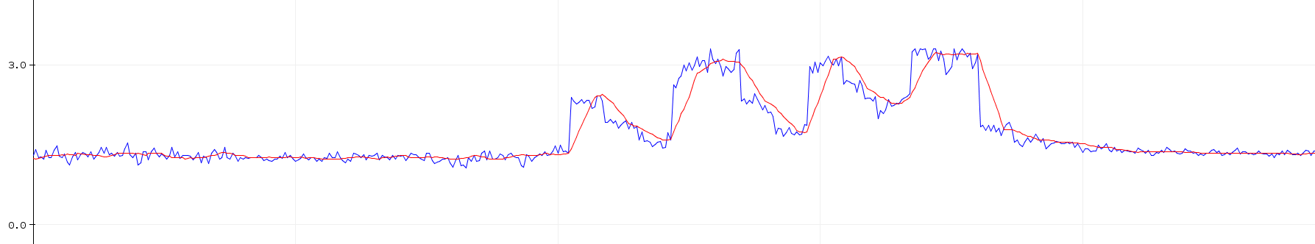

2.
Median (window 5)
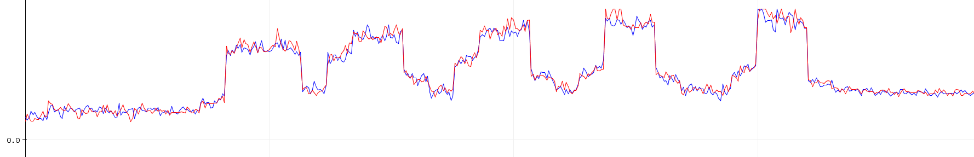

3.
exponential / 1st order iir (alpha = 0.25)
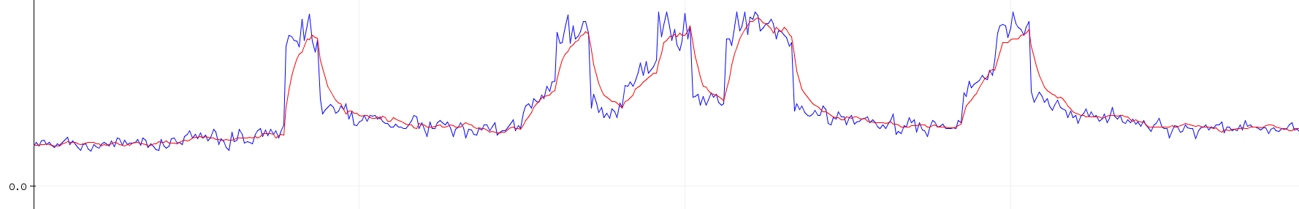
exponential / 1st order iir (alpha = 0.5)
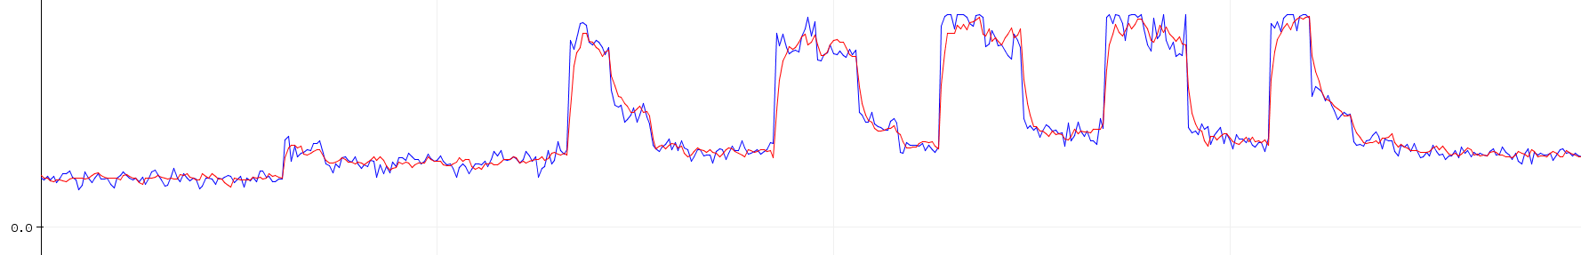
exponential / 1st order iir (alpha = 0.75)
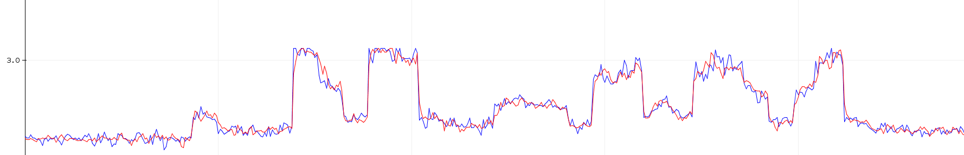

4.
butterworth 2nd order lpf (cutoff = 2Hz, Q = 0.707)

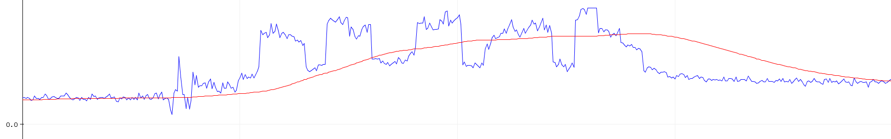
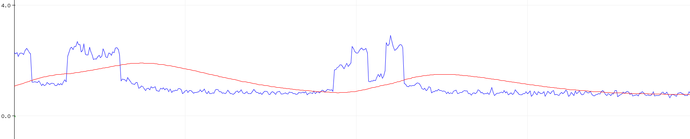

butterworth 2nd order notch (cutoff = 5Hz, Q = 0.707)
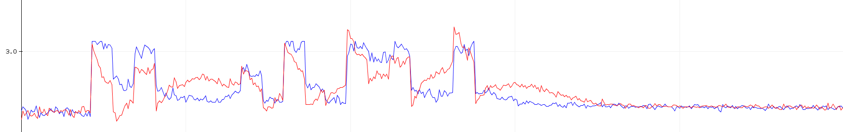
butterworth 2nd order hpf (cutoff = 10Hz, Q = 0.707)
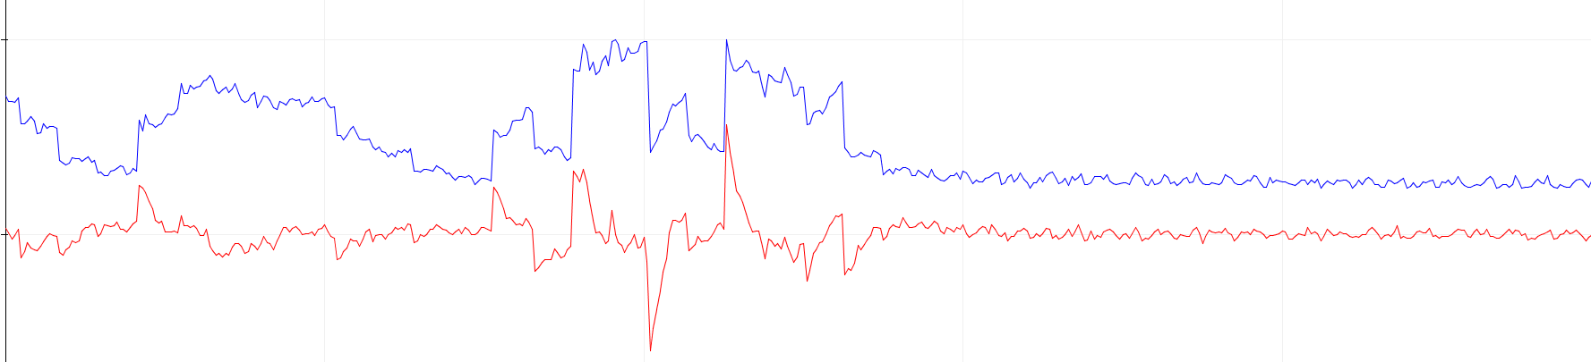
butterworth 2nd order bpf (cutoff = 4Hz, Q = 0.707)
